**Customer Segmentation Framework**

1. SVD:

For any matrix $A, A∈R^{n×m}$, it turns out that $A$ can be decomposed by two orthogonal matrix U and V and a diagonal matrix $Σ$ as following:

$$A=UΣV^{T}, U∈R^{n×r},Σ∈R^{r×r},V∈R^{r×m}$$

SVD is very popular in image compression. In NLP, the latent semantic analysis (LSA) use SVD to mining the latent semantic class or hidden topics of different documents. Moreover, in NLP many similar model such as Latent semantic indexing (LSI), latent factor model (LFM) are all very close to LSA whose core algorithm is just SVD. In the recommendation system, people use collaborative filtering model (CF) to recommend top-N items for users, whose one of core algorithm is also SVD and its variants.

In terms of the collaborative filtering model (CF):

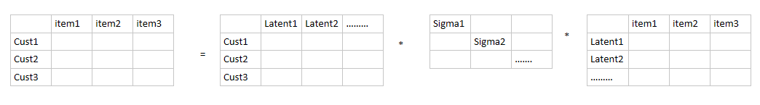

The entry in each row represents the ratings that a customer give to a specific item. We can decompose the matrix as three-matrix multiplication. The left matrix is the ratings or interests a customer has for different latent fields, such as sports, games, movies, food, travel and so on. The number of such latent fields is arbitrary, but it turns out that some of the sigma will contain most of the information of that matrix. Therefore, we can only keep some sigma on the diagonal. For instance, we only keep k number of sigma, then the matrix A can be decomposed as following:

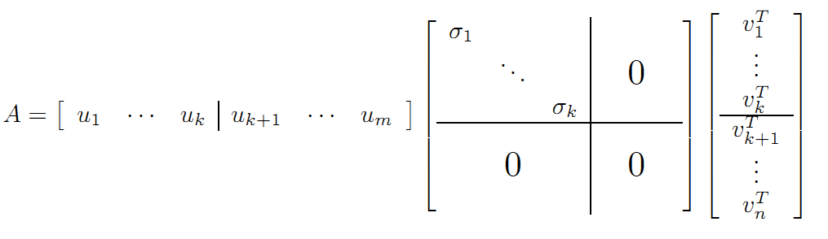

Based on the knowledge of block matrix, because the upper left corner submatrix is the only non-zero matrix in the block matrix, the left matrix U and right matrix V can be embedded into lower dimension. Therefore, we have following conversion:

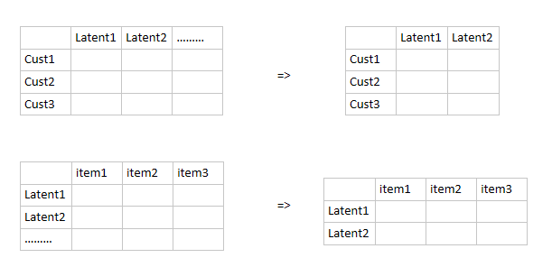

The left matrix represents the interest rating a customer to a specific latent fields, the right matrix represents the correlation coefficients or weights between the latent fields and different items. The middle sigma diagonal matrix tells us which latent fields should be remained. However, in the practical, the original matrix A is very sparse, because a customer can only rate or purchase tiny part of all items (products). Therefore, many entry of the matrix A will be missing value. Such matrix can’t be decomposed by SVD. Usually, mean or median value will be plug into the empty entry in order to solve this issue. Some optimization solution developed to solve this issue such as funk-SVD. It turns out that funk-SVD is very efficient and popular. Afterwards, the filled matrix can be decomposed and we only keep some of sigma with big values. Then we multiply three matrix to reconstruct the previous matrix A and use such reconstructed matrix to substitute previous one. Eventually, the top-N recommendation task is very easy, based on the reconstructed matrix, for each customer (for each row), we rank the items rating and choose the top-N-items with the biggest rating value.

In terms of LSA/topic model, we have tfidf-matrix. Very similar to above CF model:

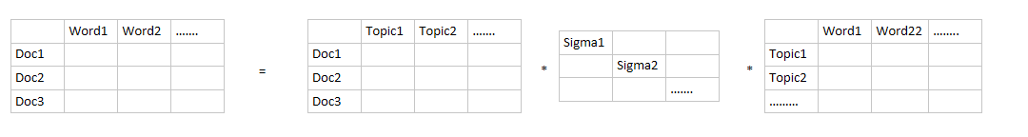

Similarly, if we only keep two latent topics here, we will have following conversion:

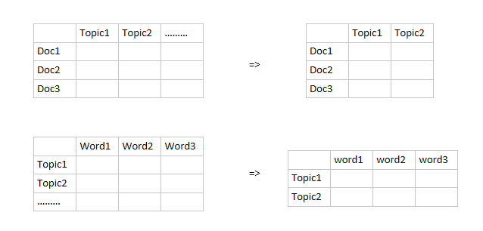

The reconstructed matrix is as following:

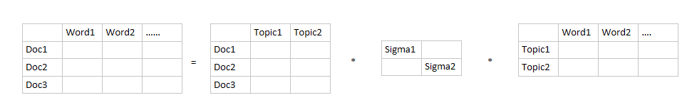

The topic model can help us cluster documents based on the latent topic distribution. The first matrix on the right hand side of the equal sign represents the correlation weights between each document and each latent topic. The third matrix is represents the correlation weights between each latent topic and each word. The middle diagonal matrix decide which latent topics should be remained in the model.

The customer segmentation issue is the most fundamental and important issue in the financial industry especially in the bank industry. The common methods and procedures of customer segmentation is from the business perspective. Specifically, the customer acceptance and on-boarding process applies to all new customers, CIP and CDD have to apply to all customers to make sure bank has completed the basic identification and investigation on each customer.

Based on the CIP and CDD information, bank is able to perform customer segmentation. For instance, bank usually segment customers into individual and non-individual, furthermore, individual can be split as natural individual and legal individual, non-individual can be split as bank, non-bank division. On the other hand, from the customer social and attributes perspective, customer can be classified as individual, government, entity.

However, the above customer segmentation do not consider the transaction behaviors and financial behavior of a customer. The issue is many models in bank industry require not only the static customer segmentation but also require the customer segmentation based on the historical transaction and the previous transaction behavior of the customer. Such segmentation method is data driven and dynamic and is able to find the hidden pattern behind the customer’s financial behavior.

This article try to apply the LSA model in NLP to the customer segmentation issue. Firstly, we need to classify the rationale behind this application.

The transaction table for each customer is as following:

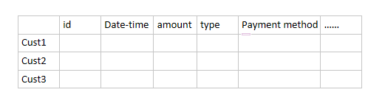

The transaction has many features, we can concatenate some of features as a string.

Suppose we have three features for a transaction:

Txn: F1, F2, F3

Such transaction can be concatenated to following words:

Txn: F1, F2, F3🡪’F1’, ’F2’, ’F3’, ’F1_F2’, ’F2_F3’, ’F1_F3’, ’F1_F2_F3’

FICO convert each transaction to a highest ordered interaction item

Txn: F1, F2, F3🡪’F1_F2_F3’

We should consider not only the highest order interaction item but also low order interaction item. In our case, one txn will be converted to many words as above. Such a word we call it one txn pattern.

Each customer has a bunch of transactions, each transaction has many words (patterns). If we group/collect all words for a customer, then such group of words consist a document. Therefore, a customer is just a document in LSA, a txn pattern here is just a word in LSA.

We don’t need to consider the sequence information because LSA is a bag of word model.

Therefore, we can convert the customer segmentation issue to a normal LSA issue as following:

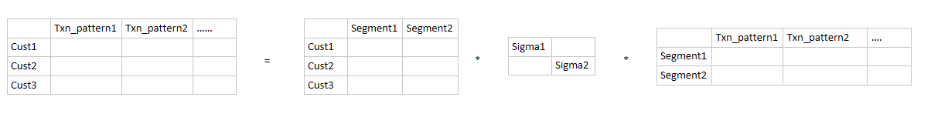

The first matrix on the right side of equal sign represent the distribution of correlation weights between customer and the latent segmentation. The segment with biggest value for a customer in the left matrix is the belonging segment for this customer.

Before we dive into the above application, let’s take a look at following formula again and reconsider the matrix decomposition from the perspective of subspace and transformation.



The first left matrix on the right side of equal sign is matrix U which is consisted of orthogonal basis of m-dimension vector subspace. Similarly, the third decomposed matrix V is consisted of orthogonal basis of n-dimension vector subspace. However, is there any way that we can make sure these two subspaces to be the same subspace so that all column vectors in U and row vectors in V represent the same orthogonal basis? Here you can imagine this matrix A is just the tfidf-matrix or the customer-transaction pattern matrix.

The answer is YES! But an issue occurs: Since matrix A is too general, even the row amount and column amount are different. So intuitively we need to constrain A to be a square matrix. But only square matrix is not enough. Based on the Linear Algebra theorem, to guarantee square matrix A can be decomposed to a diagonal matrix, we have to constrain matrix to be symmetric. Once based on following theorem everything will be clear:

Any real symmetric matrix $A, A∈R^{m×m}$ can be decomposed as following:

$$A=PΣP^{T}$$

P is orthogonal matrix which is consisted of orthogonal basis in k-dimension subspace, k is the rank of A. The matrix $Σ$ is diagonal and can be ranked from biggest value to smallest on the diagonal. We can think of this theorem as a particular situation of SVD. Adding the constraints on A will bring us many benefits, the biggest one as we talk above is we find a set of orthogonal basis in k-subspace. BUT what is the use of this set of orthogonal basis?

As we all know from linear algebra, the matrix P is called orthogonal matrix and orthogonal matrix is consisted of orthogonal basis, we can write $P=\left(p_{1}…p_{m}\right),p_{i}$ is a set of orthogonal basis. Recall the regression part, suppose we have a predictor coefficient matrix $X, X∈R^{n×m}$, each column in X is one feature or predictor vector. $X=\left(X_{1},X_{2},….X_{m}\right), X_{i}∈R^{n}$, assume the rank of matrix X is m which means X is full rank in column.

Therefore, any column vector of X can be linear represented by m original orthogonal basis: $e_{1}={\left(1,0,0…\right)}^{T}, e_{2}={\left(0,1,0….\right)}^{T},e_{3}={\left(0,0,1…\right)}^{T}….e_{m}={\left(0,0…1\right)}^{T}$.

Coordinate Value based on different orthogonal basis

suppose $α={(α_{i1}….α_{im})}^{T}$ is the coordinate vector of $X_{i}$ on the basis of $e_{i},i=1..m$. Then $X_{i}$ can be represented by basis $e_{i}$ as following:

$$X_{i}=\left(e_{1}…e_{m}\right)\left(\begin{matrix}α_{i1} \\ ⋮ \\ α_{im}\end{matrix}\right)=\sum_{j=1}^{m}{α_{ij}}e_{j}$$

But the question is how to represented the same column vector by other orthogonal basis? Suppose there is an orthogonal matrix $P=(P_{1},P_{2},….P_{m})$, also we know all $P_{i}$ is orthogonal basis just like $e_{i}$, Then we have:

$$X_{i}=PP^{T}X_{i}=(P_{1},P_{2},….P_{m})P^{T}X_{i}$$

Here if we focus on $P^{T}X_{i}$, you will find it is also a column vector:

$$P^{T}X_{i}=\left(\begin{matrix}{P_{1}}^{T} \\ ⋮ \\ {P_{m}}^{T}\end{matrix}\right)\left(e_{1}…e_{m}\right)α=\left(\begin{matrix}{P_{1}}^{T}α \\ ⋮ \\ {P_{m}}^{T}α\end{matrix}\right)$$

Therefore, $X_{i}=\left(P_{1},P_{2},….P_{m}\right)\left(\begin{matrix}{P_{1}}^{T}α \\ ⋮ \\ {P_{m}}^{T}α\end{matrix}\right)=\sum_{j=1}^{m}{{P_{j}}^{T}α}P_{j}$

Notice that ${P_{j}}^{T}α$ is a scalar value. Thus, we know ${({P_{1}}^{T}α….{P_{m}}^{T}α)}^{T}=P^{T}α$ is the coordinate vector of $X_{i}$ on the basis of $P_{i},i=1..m$.

Let’s look an example, suppose there are two points on the coordinate graph (X,Y), the coordinate value of points A, B as shown on the graph. The original orthogonal basis is X=(1,0), Y=(0,1). Suppose we have an orthogonal matrix P:

$$P=\left(\begin{matrix}\frac{\sqrt{2}}{2} & -\frac{\sqrt{2}}{2} \\ \frac{\sqrt{2}}{2} & \frac{\sqrt{2}}{2}\end{matrix}\right)$$

Based on the above discussion, we know $P=$ ($P_{1},P_{2}), P_{1}={(\frac{\sqrt{2}}{2},\frac{\sqrt{2}}{2})}^{T}, P_{2}={(\frac{-\sqrt{2}}{2},\frac{\sqrt{2}}{2})}^{T}$

Therefore, the coordinate vector of A, B on the basis of $P_{1}, P_{2}$ is:

$$A=P^{T}{(\frac{\sqrt{2}}{2},\frac{\sqrt{2}}{2})}^{T}=(1,0)$$

$$B=P^{T}{(\frac{-\sqrt{2}}{2},\frac{-\sqrt{2}}{2})}^{T}=(-1,0)$$

Take a look at following graph. It is obvious that the new orthogonal basis $P_{1}, P_{2}$ is just the green line coordinate system. Until now we can answer the first question above BUT what is the use of this set of orthogonal basis? Because when we use different basis to represent vector the coordinate vector for the same vector will be very different. Just as the above calculation result shows, the coordinate vector of A is from $(\frac{\sqrt{2}}{2},\frac{\sqrt{2}}{2})$ to $(1,0)$ and B is from $\left(\frac{-\sqrt{2}}{2},\frac{-\sqrt{2}}{2}\right)$ to $(-1,0)$. However, does this coordinate transformation really matter? What benefits does this coordinate transformation bring to us?

An obvious benefit we have now is we convert all coordinate value of P2 to zero after we use $P_{1}, P_{2}$ to represent A and B points. That means when we measure the variability of points A, B, we do not need $P_{2}$ dimension anymore. Since this dimension do not contain any variability information. From this perspective, we actually reduce the dimension after using $P_{1}, P_{2}$ to represent A and B points. The variability here is just the covariance matrix of points A and B. When we use X, Y as basis, the covariance matrix is $\left(\begin{matrix}1 & 1 \\ 1 & 1\end{matrix}\right)$, but when we use $P_{1}, P_{2}$ as basis, the covariance matrix is $\left(\begin{matrix}2 & 0 \\ 0 & 0\end{matrix}\right)$. It is obvious that basis switch is able to convert covariance matrix to a diagonal matrix. It is also very easy to understand because covariance value is determined by the selection of basis. Different basis will generate different covariance matrix. Therefore, we need to find a set of orthogonal basis to make sure the corresponding covariance matrix will have the best interpretability. It is apparent that the diagonal covariance matrix should has the best interpretability, since it only contains variance which means the direction of such basis we select can explain the most of variability of the data.

$$P_{2}$$

Y

B

A

$$B=(\frac{-\sqrt{2}}{2},\frac{-\sqrt{2}}{2})$$

$$A=(\frac{\sqrt{2}}{2},\frac{\sqrt{2}}{2})$$

$$P_{1}$$

X

We know that the covariance matrix for any predictor coefficient matrix X has following expression if we standardize each column vector of X, we will have:

Suppose o= (1, 1, ….1) is n dimension real vector.

$${X=( X}_{1}-\overline{X_{1}},….X_{m}-\overline{X_{m}}), \overline{X_{i}}=\frac{1}{n}oX_{i}o^{T}$$

Then we have

$$XX^{T}={( X}_{1}-\overline{X_{1}},….X_{m}-\overline{X_{m}}){{( X}_{1}-\overline{X_{1}},….X_{m}-\overline{X_{m}})}^{T}$$

$$=\sum_{i=1}^{m}{{(X}_{i}-\overline{X_{i}}){(X_{i}-\overline{X_{i}})}^{T}}$$

We can only take a look at one item in above sum, suppose the coordinate vector of ${(X}_{i}-\overline{X_{i}}$) is $α={(α_{i1}….α_{in})}^{T}$:

$${(X}_{i}-\overline{X_{i}}){\left(X_{i}-\overline{X_{i}}\right)}^{T}=\left(\begin{matrix}{α_{i1}}^{2} & ⋯ & α_{i1}α_{in} \\ ⋮ & ⋱ & ⋮ \\ α_{in}α_{i1} & ⋯ & {α_{in}}^{2}\end{matrix}\right)$$

Then we sum all of items together, then we have:

$$XX^{T}=\sum_{i=1}^{m}{{(X}_{i}-\overline{X_{i}}){\left(X_{i}-\overline{X_{i}}\right)}^{T}}$$

$$=\sum_{i=1}^{m}{\left(\begin{matrix}{α_{i1}}^{2} & ⋯ & α_{i1}α_{in} \\ ⋮ & ⋱ & ⋮ \\ α_{in}α_{i1} & ⋯ & {α_{in}}^{2}\end{matrix}\right)}$$

$$=\left(\begin{matrix}\sum{{α_{i1}}^{2}} & ⋯ & \sum{α_{i1}α_{in}} \\ ⋮ & ⋱ & ⋮ \\ \sum{α_{in}α_{i1}} & ⋯ & \sum{{α_{in}}^{2}}\end{matrix}\right)$$

$$\frac{1}{n}XX^{T}=\left(\begin{matrix}\frac{1}{n}\sum{{α_{i1}}^{2}} & ⋯ & \frac{1}{n}\sum{α_{i1}α_{in}} \\ ⋮ & ⋱ & ⋮ \\ \frac{1}{n}\sum{α_{in}α_{i1}} & ⋯ & \frac{1}{n}\sum{{α_{in}}^{2}}\end{matrix}\right)$$

Since the mean of vector $α$ is zero, so above matrix $\frac{1}{n}XX^{T}$ is just the covariance matrix of X.

Because $XX^{T}$ is always symmetric and furthermore it is positive definite which means all eigenvalues are positive, so we can rank all positive eigenvalues on the diagonal just as SVD.

Let’s go back to see the above theorem:

Any real symmetric matrix $A, A∈R^{m×m}$ can be decomposed as following:

$$A=PΣP^{T}$$

This guarantee that the covariance matrix of any matrix X (after standardized on each column) can be converted to a diagonal matrix by searching a set of orthogonal basis and such basis always exists. The whole process of searching orthogonal basis and represent coordinates vector by such basis is PCA. The benefits of PCA is:

1. By using proper basis to represent coordinates vector, the covariance matrix of predictor coefficient matrix X can be converted to a diagonal matrix. This means we find some best basis to explain the variability of data.
2. By ranking the diagonal values from biggest to smallest, we can find the sum of part top diagonal values occupies big ratio of total sum, which means only keeping that part of diagonal values can explain the most of variance of data. This will convert other diagonal values to be zero. As discussed above, the block zero sub-matrix will reduce the dimension and all predictor vectors can be linear represented by lower dimension subspace without losing much information.
3. From old basis to new basis, there is an orthogonal transformation apply such conversion. This orthogonal transformation can tell us which predictors should be linear combined together as a basis. This can be certified by some domain knowledge.